Union Territory (UT) Profile

UT of LADAKH
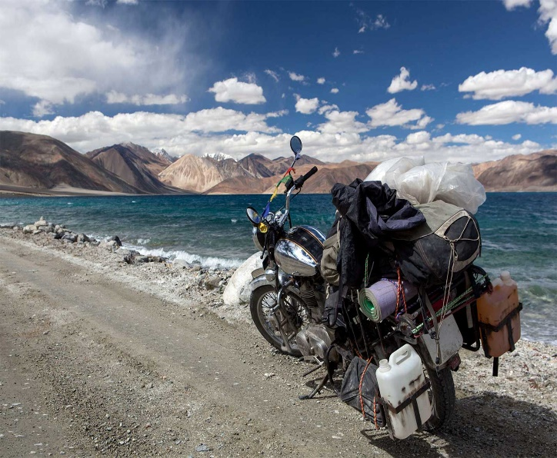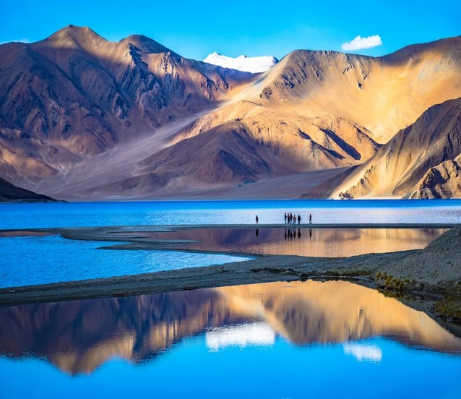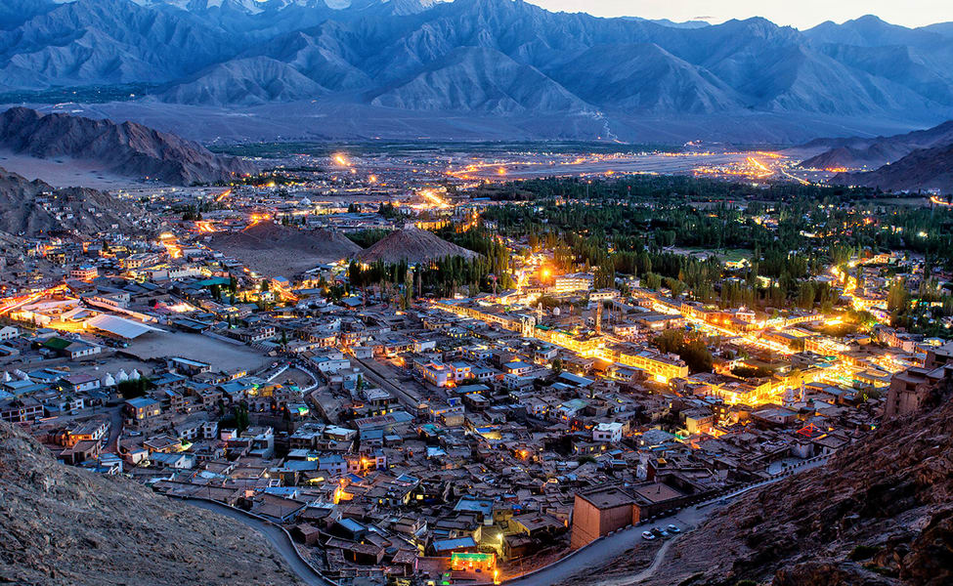
FINANCIAL INCLUSION AND DEVELOPMENT DEPARTMENT
RESERVE BANK OF INDIA, JAMMU
UT PROFILE - LADAKH
MARCH 31, 2025

Contents
1. Physical Features 3
2. Infrastructure 6
3. Agriculture and agricultural infrastructure 9
4. Banking Facilities 14
5. Performance of Banks 15
6. Industry 15
7. Lead Bank Scheme 17
8. Government sponsored programmes/schemes 18
9. Regional Rural Banks 19
10. Local Area Bank (LAB) 19
11. Small Finance Bank 19
12. Credit Delivery: Innovative Programmes 19
13. Financial Institutions 20
14. Role of NABARD 20
15. Recovery 23
16. Centres for Financial Literacy (CFL) 23
17. Other Matters 23

1. Physical Features
(i) Map - Union Territory of Ladakh
The map of new Union Territory of Ladakh, as created on October 31, 2019, is shown below.

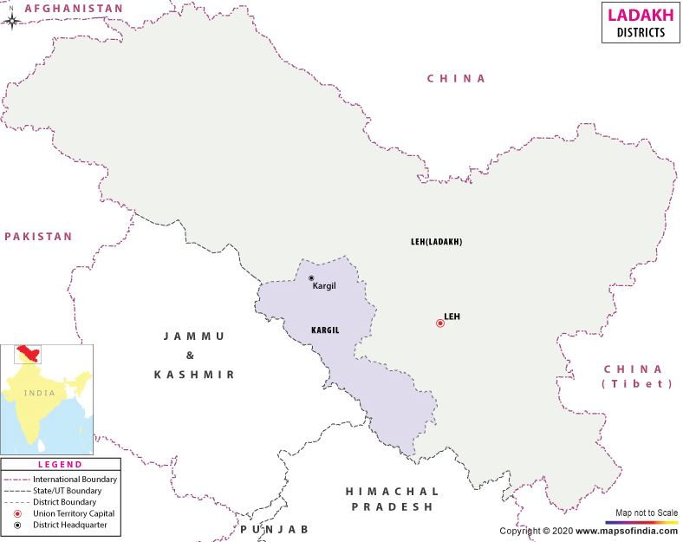

(ii) Location
Ladakh, known as the “Land of High Passes”, is situated between 2550 meters (8370 feet) and 7742 meters (25400 feet) above sea level, with an average latitude of 34°09′51″North and longitude of 77°35′05″ East. In term of geography, it is bordered by the Great Himalayas to the south, the Zanskar Range to the west, and the Karakoram Range to the north, along with the Saltro Range. Key rivers such as the Indus, Suru, Zanskar and Shayok flow through the region, shaping its arid landscape .It comprises of two districts—Kargil and Leh (In pursuit of Prime Minister Shri Narendra Modi's vision to build a developed and prosperous Ladakh, Ministry of Home Affairs has decided to create 5 new districts in the Union Territory namely Zanskar, Drass, Numbra, Sham and Chungthang).

(iii) Climate and Rainfall: The region experience as extreme cold desert climate due to its arid landscape and high-altitude environment with long and harsh winter with temperatures plummeting upto -30° Celsius. Annual precipitation is extremely low, averaging less than 100mm. Despite these harsh conditions, the region enjoys approximately 300 sunny days per year.
Ladakh lies in the rain shadow region of the Himalayas where dry monsoon winds reach Kargil after its moisture has been used in the plains and the Himalayas. Ladakh combines the conditions of both arctic and desert climates. Therefore, Ladakh is often called as “Cold Desert. Leh contains the Indus, Shyok and Nubra river valleys while Kargil district contains the Suru, Dras and Zanskar river valleys. The Indus River is the backbone of Ladakh. Most of the major historical and current towns — Shey, Leh, Basgo and Tingmosgang, are close to the Indus River.

(iv) Soil Type: Majority of the soils in Leh and Kargil district are sandy to sandy loam in texture and medium to medium-high in organic matter with poor water holding capacity.

(v) Demography : In August 2019, the Parliament of India passed a reorganization act establishing Ladakh as a separate Union Territory, effective from 31 October 2019. It is the largest Union Territory in term of area covering 59146 square kilometres, and is one of the least populated regions in the country with a population density of 5 persons per sq. Km. As per the 2011 Census, the total population of Ladakh is 274289 across its two districts, Leh and Kargil. The local population speaks a range of languages, including, Ladakhi, Purgi, Balti, Shina as well as national languages like Hindu, Urdu and English. The region’s primary religions are Buddhism and Islam.

(vi) Economic Classification of Population:
Ladakh is now a Union Territory having two districts, Leh with the Buddhist majority and Kargil is Muslim majority. Historically, subsistence agriculture and animal husbandry are the main sources of livelihood. Cultivation is only possible during summer with barely, wheat, vegetables and fruits like apple and apricot being the main crops. With scare water availability (almost no rainfall, and a reliance on glacial melt water channels and springs), the villages are scattered between small area of land in the river valleys of the Indus and its tributaries Shayok, Suru and Zanskar. A small scale farming system was developed in Ladakh. Livestock is also a major part of Ladakh’s economy. The economy of Ladakh is bases on small farmer. In the recent past tourism, small business sector and services are also the main sources of livelihood and major contributor to Ladakh’s economy.

(a) Kargil District: Kargil district was established in 1979 when it was separated from Leh district. Kargil is administratively divided into 1 district headquarter, 4 sub-divisions, 7 Tehsils, 15 administrative blocks, and 127 inhabited revenue villages (with 2 uninhabited villages0, and 98 Panchayats. As per the 2011 Census, Kargil district has a population of 140802, with 77785 males and 6017 females. Spanning a area of 14086 sr. km, the district has a population density of 10 persons per sq. km. The sex ration stands at 810 females for every 1000 males, and the literacy rate is recorded at 71.34%

(b) Leh District : Leh is the second largest district in India and comprises of 119 inhabited Revenue Villages and 1 uninhabited village. The district comprises of the total of 1 district headquarter, 6 sub-divisions, 8 Tehsils, 16 administrative blocks and 95 Panchayats. Leh serves as the district headquarter. According to the 2011 Census, the population of Leh district is 133487, with a population density of 3 persons per sr. km. The district has a literacy rate of 77.20% (with 86% for males and 64% for females). The sex ratio is 690 females per 1000 males.

(vii) Culture & Heritage: The most attractive feature of the landscape of Ladakh are the Buddhist situated on the isolated hillock in the vicinity of villages, these aesthetically pleasing, architecturally interesting monasteries provide the focus for the faith of the highly religious Buddhist people. Monasteries are the places of worship, isolated meditation and religious instruction for the young. Monasteries have a wealth of artefacts, Lamayuru, the oldest religious centre of Ladakh, beats all other in sheer grandeur. In its uniqueness of wood carving, statues and frescoes, Alchi offers the highest rewards. The wealth of its possession and its annual summer festival make Hemis the most popular, while Thiksay rates high in terms of architectural impact and the beauty of the festival performances at Likir and Phyang with their proximity to Leh are great attractions in their favour while the accessibility of the Shey, Spituk and the Sankar monasteries make them suitable for visitors with time at a premium. Besides monasteries, the 9 storey Leh Palace, Stok Palace Museum, Mahabodhi International Meditation Centre and the Central Institute of Buddhist Studies Choglamsar, Mosque and Moravian Church at Leh are added attraction for the tourists.

2. Infrastructure
(i) Power: Ladakh possesses immense hydroelectric potential, making hydro energy the primary and most economical source of power in the region. Currently, the Union Territory hosts two major hydro power projects operated by NHPC:
• Nimoo Bazgo Hydro Power Project in Leh district with an installed capacity of 45 MW
• Chutak Hydro Power Project in Kargil district with a capacity of 44 MW.
In addition, there are Small Hydro Power Projects (SHPs) with a combined capacity of 10.56 MW operating in both Leh and Kargil districts.
Two other hydro projects are in progress:
• Dah Hydro Project (partially commissioned) – capacity: 9.00 MW
• Hanu Hydro Project (under construction) – capacity: 9.00 MW
To meet the energy demands in remote areas, the Ladakh Power Department operates 46 diesel generator (DG) stations across various villages, with a total installed capacity of 14.33 MW.
Furthermore, two Mini/Micro Hydro Projects, one each in Leh and Kargil districts, are managed by LREDA (Ladakh Renewable Energy Development Agency) and KREDA (Kargil Renewable Energy Development Agency) respectively.

Renewable energy is energy derived from natural resources that replenish themselves in less than a human lifetime without depleting the planet’s resources. Ladakh has a potential to generate 35 GW from solar energy and 04 GW from wind energy. At present hydro and solar energy play an important role in power generation and rural electrification in Ladakh. Hydroelectricity from small hydroelectric plants (installed capacity 8.5 MW) accounts for about 60% of the total electricity generation. Currently, approximately 7000 solar photovoltaic (PV) domestic lighting systems provide electricity for lighting to about 25% of the households in Ladakh. The Ladakh region gets approximately 320 days of sunshine for a year and is one of the best places in the world for solar cooking. The Ladakh Renewable Energy Development Agency (LREDA), the nodal agency of the MNRE is currently implementing renewable energy technologies across the region.
Prime Minister Narendra Modi has been advocating for Green Hydrogen as an indigenous mobility option. Near Leh in Ladakh, at Choglamsar Village, NTPC Ltd has set up a demonstration plant to produce Green Hydrogen.This is the world’s highest-altitude green hydrogen fueling station. Ladakh, a cold desert, is well-endowed with sunlight, boasting over 300 cloud-free days a year. Here, NTPC has installed a 1.7-megawatt solar photovoltaic plant. NTPC estimates that the plant will produce 80 kg of hydrogen daily, enabling five intra-city fuel-cell electric buses to operate around Leh, covering a combined 1,100 kilometres per day.

The Puga geothermal field is located in the south-eastern part of Ladakh and has been recognized as the most intense geothermal field in India. At an altitude of about 4400 m, it forms a part of the Himalayan geothermal belt. It is estimated to have the capacity to generate 30-40 MW of electricity at a temperature of 240 °C at relatively shallow depths Ladakh is an area endowed with substantial natural resources. It has natural advantage due to the cloudless days and a clear mountain sky. These unconventional resources could make Ladakh carbon neutral and energy self-sufficient.

(ii) Transport: Transport in Ladakh faces challenges, due to its rugged terrain. The regions road network connects key hubs like Leh and Kargil, with major highways such as the Leh-Manali, and Leh Srinagar roads. Efforts to improve transport are underway, with projects like the Zojila Pass tunnel aimed at providing year round connectivity. These developments are crucial for boosting tourism, local economies and overall accessibility in the region. The administration at UT is actively championing the adoption of Electric Vehicles (EVs) and promoting sustainable transportation solutions. This initiative is Show cased through the introduction of a fleet of state-of-the-art electric buses and Cars which are designed to reduce carbon emissions and enhance environmental sustainability. By integrating these eco-friendly vehicles into their transportation network, UT aims to set a progressive example in green mobility, encouraging the community to embrace cleaner transportation alternatives for a healthier planet.

(iii) Roads: The majority of roads in Ladakh are looked after by the project Vijayak. The Leh –Srinagar in one of the only two roads that connected Ladakh with the rest of India with 440kms, known as Srinagar-Leh (NH-1D), the Leh-Manali Highway is almost 428kms is known as NH-03 and other is Kargil-Zanskar is approximately 234kms known as (NH-301). Almost all the villages of UT Ladakh are connected with roads. Roads maintained by PWD are 890.70kms in Leh district and 133.48kms in Kargil district, total 1024.18 in UT Ladakh. Roads maintained by project Vijayak are 4627.34kms in Leh district and 1326.78kms in Kargil district, total 5954.15kms in UT Ladakh. There is no rail connectivity in UT Ladakh.

(iv) Civil Aviation: The Kushok Bakula Rinpoche Airport in Leh serves as the primary year round link to the rest of India.

(v) Irrigation : The agro-climatic conditions in Ladakh present promising opportunities for horticulture and livestock management. Irrigation is facilitated through an intricate system of channels that divert water from the ice and snow of the mountains. The primary crops grown in this region include barley and wheat, with naked barley historically serving as a staple food. It is noteworthy that cultivation seasons vary considerably with altitude, and Korzok, located near Tso Moriri Lake at an elevation of 4,600 meters (15,100 feet), is recognized as hosting some of the highest agricultural fields in the world. NABARD has sanctioned a ₹16,26,893 grant to Aquamassifs Private Limited a startup for constructing automated ice resrvoirs in two villages of Leh district under CCF-ID as an adaptation measure against the adverse effects of climate. The project will lead to a 20% increase in irrigation water supply during April and May a 15% rise in cultivable area and yield a 1.25x boost in farming income significantly enhancing agricultural productivity in the region.

3. Agriculture and agricultural infrastructure
(i) Agriculture: Agriculture, particularly the cultivation of barley, wheat, and fruits like apricots, plays a crucial role in the livelihoods of rural communities, although it is limited due to the region's harsh climate and terrain. During the financial year 2023-24, the Priority Sector Lending target for agriculture was set at Rs.309.07 crore. The achievement for this sector reached Rs.211.72 crore, which is 68.50 % of the target. For the fiscal year 2024-25, the Priority Sector Lending target for agriculture has been established at Rs. 341.76 crore. As of 31 March 2025, the achievement in this sector stood at Rs. 391.95 crore which is 115 % of the target.. With the Mission for Organic Development Initiative (MODI), it is targeted that the entire UT will go organic by year 2025. Under the mission, the use of chemical fertilizers, pesticides etc. is being discouraged by the administration. NABARD has sanctioned a project for development of prototype of an Integrated Organic Farming System (IOFS) having different components of agriculture & allied fields having potential to boost the tribal farmer’s soil health, nutrition, income & livelihood security.

(ii) Horticulture: Ladakh is blessed with a conducive climate to grow planation and horticultural crops. The region falls in Northern Himalayan belt with an arid temperate climate. A number of horticulture crops are grown in Ladakh. The major horticulture crops are Apricot, seabuckthorn, walnuts, apples, grapes, herbs etc. Ladakh is the largest producer of apricot in India and it also export to other nations

Agriculture: Area Under Crops (in Hectares) in UT Ladakh.

Distt. | Year | Wheat | Barely/  Grim | Other cereals/ Maize / Millets | Pulses | Fruits & Vegetables | Oil Seeds / Spices/Other Food Crops | Fodder | Total Area Irrigated
Leh | 2023-24 | 2394.58 | 3841.13 | 394.00 | 216.20 | 439.20 | 332.08 | 2362.45 | 9979.64
Kargil | 2023-24 | 2125.90 | 5316.00 | 18.72 | 952.60 | 668.20 | 03.00 | 2669.78 | 11754.20
Total |  | 4520.48 | 9157.13 | 412.72 | 1168.80 | 1107.40 | 335.08 | 5032.23 | 21733.84

(iv) Farm Mechanization: Farm Mechanization is one of the technological inputs that is required to improve the process which can transform the subsistence farming to commercial farming. Agricultural implementation and machines enable the farmers to employ the power judiciously for production purposes. There is a growing trend to go for new machineries and equipment, considering the acute shortage and high cost of labour, especially during sowing and harvesting seasons. The demand for farm mechanization is no longer confined to Tractors, Power Tillers, but also for rotavators, power weeders, combined harvesters etc.
The credit potential assessed by NABARD under Farm Mechanization is Rs. 8.39 Cr (Kargil-3.89 Cr and Leh- 4.5 Cr), for 2025-26.

(v) Animal Husbandry:
(a) Dairy : Dairy products are not only an important source of protein for people of Ladakh but it also has a huge potential to generate income from them. In 2019, Ladakh produced 31000 tonnes, i.e., 280 grams/capita/day. According to the 20th Livestock Census, which was done in 2019, there are more than 35,000 cattle in the Leh-Ladakh region. There are about 22,000 native breeds and about 13,000 exotic breeds. The total credit potential for the UT assessed for the year 2025-26 is ₹7195.82 lakh.
(b) Poultry: Today poultry farming has transformed itself into an organized industry. Poultry sector not only plays an important role in fighting against malnutrition but also plays a major role in reducing unemployment and underemployment. Eggs and poultry meat are important sources of low cholesterol, high quality animal proteins. Poultry meat provides all essential amino acids for human body. Poultry farming provides subsidiary occupation to small and marginal farmer. It is very difficult in the cold arid Himalayan region of India. The harsh climatic environment is characterized by hypobaric-hypoxia, low humidity, high UV radiation and extreme variation in ambient temperature (-20 to +30ºC), which causes high-altitude stress to poultry. The credit potential assessed for the year has been ₹438.86 lakh.

(vi) Fisheries Department: The Fisheries Department, UT of Ladakh has started with the establishment of fish farm at Shey in 1960. Production of fish for revenue generation, creating job opportunities for educated youth and initiating awareness programmes on conservation of indigenous fishes and fish farming for self-employment generation are main activities of Fisheries Department, Leh. A project for promotion of a fish FPO in the district is being implemented by Krishi Vigyan Kendra, Leh. The department manages 10 fish farms across Ladakh where rainbow trout fish are reared and supplied to public.

(vii) Solar power, solar farming, irrigation including water harvesting and rain-water management:
Solar power is a renewable energy source that harnesses sunlight to generate electricity using solar panels. It's clean, sustainable, and plays a key role in reducing carbon emissions and dependence on fossil fuels. Solar farming, also known as solar agriculture or photovoltaic farming, involves installing large arrays of solar panels across fields or unused land to produce electricity on a much larger scale. These solar farms can power homes, businesses, and even entire communities. In some cases, solar farming is combined with traditional agriculture—a practice called agrivoltaics—allowing crops to grow beneath the panels while energy is generated above, maximizing land use and boosting efficiency.
Solar power is especially important in Ladakh due to its high altitude, clear skies, and abundant sunlight throughout the year, making it ideal for harnessing solar energy. With over 300 days of sunshine annually, the region is ideally positioned to harness solar power for sustainable energy production. This renewable energy source could play a pivotal role in reducing the local economy's reliance on fossil fuels, which currently contributes to environmental degradation and air pollution.
The PM Surya Ghar: Muft Bijli Yojana, launched by the Government of India, is one of the most important schemes for Ladakh. The scheme aims to provide free electricity to households by promoting rooftop solar panel installations. Under this scheme, households can receive subsidies to install solar panels, allowing them to generate their own electricity and reduce dependence on the grid. The initiative targets reducing electricity bills, promoting renewable energy, and making India self-reliant in power generation. Under PM-Surya Ghar Muft Bijli Yojana, subsidy up to 60% (Central and UT subsidy put together) is available for installation of rooftop solar panels.
Passive solar housing and solar irrigation systems represent promising opportunities in Ladakh for sustainable development, offering significant potential for interventions that can lead to energy efficiency, reduced carbon footprints, and improved resource management in various sectors.
(viii) Warehousing Ladakh possesses an agro-storage capacity estimated at approximately 42000 metric tons (MT). This storage infrastructure is primarily overseen by the Food Corporation of India (FCI) and the Department of Food and Civil Supplies, which manage the stockpiling of essential Public Distribution System (PDS) food items. Agriculture in this region tends to be of a subsistence nature, characterized by small-scale farming practices focused on meeting local needs rather than generating surplus for broader markets. Traditional crops cultivated in Ladakh, such as wheat and barley, are typically produced in modest quantities, limiting the availability of excess agricultural produce for storage. This situation underscores the challenges faced by farmers in the region as they work to sustain their livelihoods against the backdrop of a harsh and often unpredictable climate.

(x) Plantation: Plantation of agroforestry, medicinal plants, fruits and vegetables can help in management of wastelands and restoration of poor agricultural lands. An integrated tribal development project is being implemented by Ladakh Framers and Producers Cooperative Limited (LFPCL) at Ranbir Thiksay. The project is being implemented in a large tract of wasteland that was allocated to the families of Rambirpura village. It is a unique project where plantation is collectively undertaken on 311-acre land which is considered as a single Wadi belonging to the community. .
(xi) Status of Farmer Producer Organization (FPOs): FPOs are organizations formed by groups of farmers or primary producers to collectively engage in production, marketing, and processing activities. These organizations enable farmers to pool resources, share knowledge, improve efficiency, and increase bargaining power when purchasing inputs or selling produce. FPOs are designed to help small and marginal farmers gain better access to markets, credit, technology, and government schemes, thereby enhancing their overall economic viability and livelihood security.
Two Farmer Producer Organizations (FPOs), namely the Sham Valley Apricot Producers Cooperative Limited and the Ladakh Vegetable Producers Cooperative Limited, were established with the support of NABARD through its Producer Organization Development Fund (PODF ID) in Ladakh. As of now, both of these cooperative organizations are actively operational and making significant contributions to the local agricultural landscape.

(xii) Status of digitisation of land records and adoption of Model Agriculture Land Leasing Act: The digitisation of land records in UT Ladakh is started and is under process. Digital India Land Records Modernization Programme (DILRMP) is a government initiative in Ladakh aimed at modernizing land records, reducing disputes, and enhancing transparency in land management. Under, Digital India Land Records Modernization Programme (DILRMP), computerization of land records have been completed for 23% of the villages in the UT of Ladakh.

(xiii) Status of PMFBY: Pradhan Mantri Fasal Bima Yojana (PMFBY) was launched by Hon’ble Prime Minister on January 13, 2016, across the country. At present the PMFBY is yet to be implemented in the UT.

4. Banking Facilities
UT of Ladakh has a good banking network with 17 Commercial Banks (09 Public Sector Banks and 08 Private Sector Banks), 01 Regional Rural Bank, 01 State Co-operative Bank and 01 State Financial Corporation, as on March 31, 2025. The bank network in the UT comprises of 109 bank branches with 71 bank branches in Leh district and 38 bank branches in Kargil district. The total no. of ATM’s in the UT are 164, out of which 117 and 47 are in urban and rural areas respectively. Further details are given below:

ATM and Branch Network (as on March 31, 2025)
Branch Network | Locations | Public Sector Banks | Private Sector Bank | Regional Rural Banks | Co-operative Banks | State Finance Corporation | Total
Branch Network | Urban | 20 | 23 | 2 | 6 | 2 | 53
Branch Network | Rural | 22 | 31 | 2 | 1 | 0 | 56
Branch Network | Total Branches | 42 | 54 | 4 | 7 | 2 | 109
ATM | Urban | 69 | 44 | 0 | 4 | 0 | 117
ATM | Rural | 15 | 32 | 0 | 0 | 0 | 47
ATM | Total ATM | 84 | 76 | 0 | 4 | 0 | 164

(i) Bank-wise position of Bank Mitras / BCs, as on March 31, 2025:
The Business Correspondent (BC) Agents/Bank Mitras are playing a major role in spread of financial literacy by educating the people about banking services and meeting their banking needs in far-flung / difficult areas in order to fulfil the National Mission on Financial Inclusion. There are 19 working Banking Correspondents deployed by 02 banks (J&K Bank and SBI). Further, there are 36 ultra-small branches of J&K Bank Ltd. Further details are given below:

Bank wise position of Business Correspondent and Ultra Small Branches (as on March 31, 2025)
Name of the Bank | JKB | SBI | Bank of India | TOTAL
Business Correspondent | 14 | 4 | 1 | 19
Ultra-Small Branch (USB) | 36 |  |  | 36

(ii) Financial Literacy Centers: There are two Financial Literacy Centers in UT of Ladakh and both of which are sponsored by SBI (Lead Bank). The details of which have been given below

Database on FLCs

FLC Code | District | Date of opening | Location | Premises | Address of FLC | Sponsor Bank | Whether run by trust or run directly by Sponsor Bank | Name of FL counsellor | Contact no | Email | FLC helpline
45801 | Leh | 05.03.20 | Urban | LDM office | Malpak, Leh | SBI | Yes | Vacant | Nil | Nil | Nil
43801 | Kargil | 30.09.18 | Urban | LDM office | C/o SBI Kargil Branch | SBI | Yes | Vacant | Nil | Nil | Nil

5. Performance of Banks
Deposits, advances and CD ratio as on March 31, 2025, were ₹10260.63 Cr, ₹4589.41 Cr and 44.73% respectively. Total outstanding credit in sectors of MSME and Agriculture is ₹1030.04 Cr and ₹328.69 Cr (out of which outstanding of Small & Marginal Farmers is ₹63.34 Cr) respectively.

6. Industry
There exists a rich potential for the creation of demand-driven small-scale industrial enterprises within both organized and unorganized sectors, especially in fields like handloom textiles, intricate handicrafts, and metal-based manufacturing. These sectors not only reflect the region’s cultural heritage but also hold the promise of generating significant employment opportunities for individuals who have honed specialized skills and craftsmanship.
Pashmina is a highly significant and promising industry in Ladakh, renowned for producing some of the finest cashmere in the world. The region’s unique climatic conditions and the artisanal skills of the local people contribute to the exceptional quality of Pashmina wool, derived from the undercoat of Himalayan goats. This luxurious fibre is not only a symbol of elegance but also supports the livelihoods of many families in Ladakh, creating opportunities for sustainable economic development while preserving traditional crafting techniques. As demand for authentic Pashmina products continues to grow globally, this industry holds immense potential for enhancing the economic landscape of Ladakh and showcasing its rich cultural heritage.
Ladakh Sustainable Industrial Policy 2022 - 2027 aims at harnessing its unique strengths such as its local resources, traditional skillsets by employing modern technology and exploring economic opportunities where the region has an advantage. This would be done in line with its goal of achieving Carbon Neutrality.

The Ladakh Homestay Policy 2023. The Homestay Policy 2023 of UT Ladakh was introduced to promote sustainable tourism while empowering local communities. It encourages residents to offer affordable, eco-friendly accommodations to visitors, showcasing Ladakh's rich cultural heritage and traditional lifestyle. The policy emphasizes training locals in hospitality, providing financial assistance for upgrading facilities, and ensuring adherence to eco-friendly practices. By integrating tourism with local livelihoods, the policy aims to create employment opportunities, reduce the carbon footprint, and preserve the region's fragile ecosystem, fostering a sustainable tourism model. Also a new scheme in the name of "Gram Vihar" has been introduced to give a fillip to the rural tourism sector in the country by promoting "homestay" wherein tourists stay with the local families and experience rural lifestyle as well as "away-day" i.e. one day trip without night stay.
Micro, Small and Medium Enterprises: As per Udyam registration no of units registered in UT Ladakh is 14,989 as on 31.03.2025. Credit outstanding to MSMEs under priority sector as on March 31, 2025 stands at 1030.04 ₹crore (₹870.17 crore to Micro enterprises, ₹151.2 crore to Small enterprises and ₹6.42 to Medium enterprises). There are no MSME cluster in UT of Ladakh.

7. Lead Bank Scheme
State Bank of India (SBI) is the Convenor Bank of UTLBC Ladakh. In both the districts of Kargil and Leh, the responsibilities of Lead Bank are assigned to SBI. Further, one DDM from NABARD is entrusted with DDM responsibilities in both the districts of the UT. Details of LDMs and DDM are given below .
Sr. No | District | Name of LDM/DDM | Assigned to Bank | Mobile No | e-mail
1 | Leh | Stanzin Dolkar (LDM) | SBI | 9622233367 | ldmleh2024@gmail.com
2 | Kargil | Tsering Morup (LDM) | SBI | 8491062563 | ldm.kargil@gmail.com
3 | Leh&  Kargil | Tsewang Dorjey (DDM) | NABARD | 7838181573 | tsewang.dorjey@nabard.org

(i) Steering Sub-Committee and other Sub-Committees constituted under SLBC: A UT level Sub-Committee for specific issues relating to Agriculture, MSMEs, Handicraft & Handloom and Financial Inclusion under the Lead Bank scheme.
(ii) Achievements under ACP (Annual Credit Plan) 2024-25: For the FY 2024-25, the total ACP target for the banks was ₹1887.65 Cr out of which ₹925.05 Cr was the priority sector target and ₹962.60 Cr was the non-priority sector target. Total disbursement under ACP was ₹2789.72 Cr which resulted in an achievement of 148.08%. Disbursement under priority sector and non-priority sector targets was ₹1182.32 Cr and ₹1607.40 Cr respectively, i.e. banks achieved 128% and 167% of their targets. Targets and Achi
evements of ACP under various sectors are given below: .

ACP - Sector-wise target and achievement (as on March 31, 2025)
(Amount in ₹ Crore)
Name of the Sector | ACP Target FY 2024-25 |  | Achievement as on 31st March, 2025 |  | %age of Achievement | %age of Achievement
Name of the Sector | A/c | Amount | A/c | Amount | A/c | Amount
Priority | 38369 | 925.05 | 35581 | 1182.32 | 93% | 128%
Non-Priority | 16680 | 962.60 | 20603 | 1607.40 | 123% | 167%
Total | 55049 | 1887.65 | 56184 | 2789.72 | 102% | 148%

Priority Sector: Sector-wise target and achievement (as on March 31, 2025)

(Amount in ₹ Crore)
Name of the Sub-Sector | ACP Target FY 2024-25 |  | Achievement as on  31.03.2025 |  | %age of Achievement
Name of the Sub-Sector | A/c | Amount | A/c | Amount | Amount
Agriculture | 22779 | 341.76 | 27029 | 391.95 | 115%
MSMEs | 13576 | 512.60 | 7874 | 758.95 | 148%
Export Credit | 0 | 0.00 | 0 | 0.00 | -
Education | 91 | 6.79 | 9 | 0.40 | 6%
Housing | 577 | 34.30 | 253 | 18.06 | 53%
Social Infrastr. | 88 | 2.77 | 1 | 0.10 | 4%
Renew. Energy | 500 | 7.50 | 6 | 0.10 | 1%
Others | 758 | 19.33 | 409 | 12.76 | 66%
Total | 38369 | 925.05 | 35581 | 1182.32 | 128%

Non-Priority Sector: Sector-wise target and achievement (as on March 31, 2025)

(Amount in ₹ Crore)
Non-Priority Sector
Name of the Sub-Sector | ACP Target FY 2024-25 |  | Achievement as on 31.03.2025 |  | %age of Achievement
Name of the Sub-Sector | A/c | Amount | A/c | Amount | Amount
Agriculture | 0 | 0.00 | 0 | 0.00 | -
Education  (above Rs.10.00 lac) | 4 | 0.63 | 6 | 0.65 | 103%
Housing  (above Rs.25.00 lac) | 465 | 80.29 | 600 | 120.05 | 150%
Personal Loans | 7767 | 476.51 | 6567 | 422.48 | 89%
Others | 8444 | 405.17 | 13430 | 1064.22 | 263%
Total | 16680 | 962.60 | 20603 | 1607.40 | 167%

8. Government sponsored programmes/schemes
As on March 31, 2025, total outstanding amount under GSS viz. NRLM, NULM, PMEGP, Stand Up India and SHG stood at ₹2.2 Cr, ₹0.49 Cr, ₹74.63 Cr, ₹79.1 Cr and ₹2.35 Cr respectively. Gross NPAs of banks amounted to ₹0.63 crores making it 0.40% of the total amount outstanding. Details of Disbursement under GSS are given below: .

NPAs under Government Sponsored Schemes (as on March 31, 2025):
(Amount in ₹ crores)
Scheme | Total Outstanding | NPA
NRLM | 2.2 | 0.00
PMEGP | 74.63 | 0.51
SHG | 2.35 | 0.00
NULM | 0.49 | 0.00
Stand Up India | 79.1 | 0.12
Total | 158.77 | 0.63

9. Regional Rural Banks
There are only four branches of J&K Grameen Bank (JKGB) which are functioning in the UT, three in Leh and one in Kargil district. JKGB is sponsored by Jammu & Kashmir Bank Ltd. The RRB against its target of ₹22.47 crore under Priority Sector Advances has achieved 33.24 crore (147.93% of its Priority Sector targets under ACP 2024-25).

10. Local Area Bank (LAB)
There is no Local Area Bank as on March 31, 2025.

11. Small Finance Bank
There is no Small Finance Banks as on March 31, 2025.

12. Credit Delivery: Innovative Programmes
JLGs (Joint Liability Groups) are informal groups formed by a group of individuals, typically farmers or landless laborers, who come together to obtain financial assistance or loans from financial institutions. These groups share the responsibility for loan repayment, and each member of the group is jointly liable for the loan taken by the group as a whole. This system helps individuals, who might otherwise be unable to access formal credit, particularly those without sufficient collateral. NABARD plays a crucial role in promoting Joint Liability Groups (JLGs) in India by facilitating access to institutional credit for rural farmers, landless labourer, and marginalized communities who may lack collateral. It provides financial support, including refinance facilities to banks, subsidized interest rates, and capacity-building programs to ensure JLGs are effectively formed and managed. NABARD also partners with Banks, NGOs and SHGs to promote and strengthen JLGs to ensure financial inclusion, improved livelihoods, and reduced the reliance on informal credit sources, contributing to rural economic growth..
NABARD also partners with Banks, NGOs and SHGs to promote and strengthen JLGs to ensure financial inclusion, improved livelihoods, and reduced the reliance on informal credit sources, contributing to rural economic growth.Against a target of 3,52,020 as on 31st March 2024, 3,48,890 no. of JLGs has been formed.

13. Role of NABARD
(a) Dissemination of farm technologies: NABARD has been implementing number of projects under its Farms Sector Promotion Fund for dissemination of advanced / innovative/ improved agriculture technologies for development of the agriculture sector in the UT of Ladakh. Some of the project include project of demonstration and adoption of Solar Apricot Dryers and Apricot Harvesting Nets by Tribal Farmers in Lower Sham Valley of Ladakh, project on promotion of crop diversification, project on dissemination of vermicomposting technology, project on promotion of Yak rearing and processing of Yak milk and wool for generating, project in promotion of Integrated Organic Farming System (IOFS), project on introduction of Oyster Mushrrom as an important commercial crop in tribal areas of Kargil etc.
(b) Tribal Development: An integrated tribal development project is being implemented by Ladakh Framers and Producers Cooperative Limited (LFPCL) at
Ranbir Thiksay.The project is being implemented in a large tract of wasteland that was allocated to the families of Rambirpura village. It is a unique project where plantation is collectively undertaken on 311-acre land which is considered as a single Wadi belonging to the community. The water resources for the project is being funded through a separate NABARD project under Rural Infrastructure Promotion Fund (RIPF) by lifting of water from the river Indus, storing it in tanks and then supplying through drip irrigation.
(c) Natural Resource Management: NABARD has been supporting several developmental interventions towards promoting climate resilient agriculture for sustainable livelihood promotion. It has implemented a Springshed based Watershed development project on at Sakti village to increase availabilty of water for farming. NABARD is implementing springshed based watershed project in Leh district of Ladakh. The project area is spread across 285 ha. Similarly, project on artificial glaciers is being implemented in Tsaga AND Mudh villages of Changthang. To ensure advancement and improvement in this local technology, NABARD has also started a project of Automation of Ice Reserviors in Igoo and Ayee villages of Ladakh in October 2024.

Non-Farm Sector:

In order to improve quality and sizing of products, marketing of products, establishing institutional and retail channels, NABARD has been organizing capacity building programmes for women artisans in association with TATA
Trust for handicraft products in Leh District with a broader objective of transforming an SHG to an enterprise.

My District My Project is a project which aims to improve the quality of life and incomes from improved wool craft based interventions for 200 families in six villages of Leh district. It will empower women artisans through skill development with a grant assistance of ₹11.40 lakh. It is envisaged to establish a training center for knitting and weaving in Nyoma block headquarter which will ensure continuity of skill development efforts.

My Pad My Right” project is a unique initiative of NABARD to spread mass awareness among women about menstrual hygiene and make easy availability of sanitary pads to protect them from gynecological disorders. Under this project, a sanitary pad-making machine is provided to the members to SHGs. Further training and handholding support is provided for proper operation of the machine. The project has been sanctioned in both Leh and Kargil districts.

Under the concept of Rural Marts, NABARD not only provides market access but also helps in promoting entrepreneurship amongst producer communities, SHGs etc. The scheme provides support towards operational expenditure for setting up of Rural Marts at potential locations. In this direction in order to ensure the retail marketing outlet for producers /artisans/weavers to sell their locally made products. NABARD has sanctioned 02 rural marts one each in Leh city and Nyoma block of Ladakh for providing marketing channels to SHG and FPO products.

In order to strengthen and broad-basing Pashmina and Wool Value Chain in Leh, NABARD has sanctioned a grant assistance of ₹ 107.50 lakh to an existing cooperative “Looms of Ladakh Women Cooperative Society” to scale up its operation and form a complete value chain of Pashmina and wool based products in Leh, Ladakh. The project envisages to directly impact the lives of the Pashmina weavers of Ladakh and increase their income and quality of lives significantly. A Work Studio and Training Centre covering an area of 40,000 sq ft has been constructed in Chushul, Leh.

With the initiative of NABARD Jammu & Kashmir Regional Office, Ladakh Wood Craving has become the first handicraft product from the Union Territory of Ladakh to be granted a Geographical Indication (GI) tag by the Department for Promotion of Industry and Internal Trade (DPIIT) under the Ministry of Commerce and Industry. Further, under a NABARD project, GI applications have already been filed for six more handloom / handicraft products of Ladakh.

14. Financial Inclusion: NABARD has always been at the forefront in furthering the cause of Financial Inclusion in the Country. In the UT of Ladakh NABRAD has sanctioned 8 Centers for Financial Literacy (CFL) under its Financial Inclusion Fund. In addition, NABARD has been supporting Jammu & Kashmir Grameen Bank, Jammu & Kashmir State Cooperative Bank and Commercial Banks for different activities like conduct of financial literacy camps, support for mobile banking vans, installation of micro ATMs, VSATs, POS machines etc. to ensure access to banking services in remote areas of UT Ladakh.

15. Recovery
The total outstanding amount under different sector stood at ₹1523.83 Cr as on March 31, 2025 and the Gross NPAs stood at ₹45.16 Cr which constitute 2.96% of the advances outstanding. The NPAs under Agriculture and MSME sectors stood at 5.03% and 1.99% respectively, as on March 31, 2025.

16. Centres for Financial Literacy (CFL) .
NABARD has sanctioned the establishment of eight Centres for Financial Literacy
(CFLs) as part of its initiative under the Financial Inclusion Fund (FIF). These CFLs are strategically positioned in key locations across the regions of Leh and Kargil to promote financial literacy and enhance financial inclusion among local communities.
The specific locations of these centres are as follows: Nimoo, Durbuk, Singay Lalok, and Kharu blocks in Leh district and Lotsum, Bimbhat, Karsha and Lungnak blocks of Kargil district. These centres aim to empower the residents through education about financial practices, enabling them to make informed financial decisions and foster economic growth within their communities.
As part of the Financial Inclusion Fund initiative, Mobile Demo Vans have been sanctioned to the Jammu and Kashmir State Cooperative Bank and the Jammu Kashmir Grameen Bank. This initiative aims to enhance financial literacy and promote greater financial inclusion among the rural populations of Ladakh. These mobile vans will serve as vital resources in remote areas, delivering essential banking services and educational resources directly to communities.
Furthermore, under FIF, support for the installation of advanced communication technologies, such as Very Small Aperture Terminals (VSATs) and Point of Sale (POS) systems, to facilitate better connectivity and transaction capabilities for local banks.
Various financial institutions, including J&K Bank, State Bank of India (SBI), Jammu
Kashmir Grameen Bank (JKGB), Jammu & Kashmir State Territorial Cooperative Bank (JKSTCB), and India Post Payments Bank (IPPB), have also received assistance for organizing financial literacy camps. These camps are designed to educate residents about financial management, saving practices, and the importance of utilizing banking services, thereby fostering a well-informed and financially savvy community in the region.

17. Other Matters
(i) Declaration of Natural Calamity: No natural calamity was declared during 2024-25 by the administration of Ladakh.

(ii) Performance of Rural Self Employment Training Institutes (RSETIs): .
S.No | Financial year ended | Training programme conducted | Candidate Trained | Candidate Settled | Candidates covered under Bank finance
1. | Year 2022 | 22 | 535 | 173 | 173
2. | Year 2023 | 22 | 624 | 155 | 266
3. | Year 2024 | 20 | 585 | 213 | 213

UTLBC Convenor Bank, UT of Ladakh
Press information Bureau(PIB)
UTLBC Convenor Bank, UT of Ladakh
UT Focus Paper 2025-26: Ladakh
UTLBC Convenor Bank, UT of Ladakh
UTLBC Convenor Bank, UT of Ladakh
UTLBC Convenor Bank, UT of Ladakh
UTLBC Convenor Bank, UT of Ladakh
UTLBC Convenor Bank, UT of Ladakh
Tourism Department Ladakh
UTLBC Convenor Bank, UT of Ladakh
UTLBC Convenor Bank, UT of Ladakh
Exclusive: World's Highest Green Hydrogen Plant Set Up By NTPC At Leh In Ladakh
UT Focus Paper 2025-26: Ladakh
UTLBC Convenor Bank, UT of Ladakh
UT Focus Paper 2025-26: Ladakh
UTLBC Convenor Bank, UT of Ladakh
UTLBC Convenor Bank, UT of Ladakh
UT Focus Paper 2025-26: Ladakh
UT Focus Paper 2025-26: Ladakh
UT Focus Paper 2025-26: Ladakh
UTLBC Convenor Bank, UT of Ladakh
UTLBC Convenor Bank, UT of Ladakh
UT Focus Paper 2025-26: Ladakh
UT Focus Paper 2025-26: Ladakh
UT Focus Paper 2025-26: Ladakh
UT Focus Paper 2025-26: Ladakh
UTLBC Convenor Bank, UT of Ladakh
UTLBC Convenor Bank, UT of Ladakh
UT Focus Paper 2025-26: Ladakh
UTLBC Convenor Bank, UT of Ladakh
UTLBC Convenor Bank, UT of Ladakh
UT Focus Paper 2025-26: Ladakh
UTLBC Convenor Bank, UT of Ladakh
UTLBC Convenor Bank, UT of Ladakh
UT Focus Paper 2025-26: Ladakh
UT Focus Paper 2025-26: Ladakh
UTLBC Convenor Bank, UT of Ladakh
UTLBC Convenor Bank, UT of Ladakh
UTLBC Convenor Bank, UT of Ladakh
UTLBC Convenor Bank, UT of Ladakh
UTLBC Convenor Bank, UT of Ladakh
UTLBC Convenor Bank, UT of Ladakh
UTLBC Convenor Bank, UT of Ladakh
UTLBC Convenor Bank, UT of Ladakh
UTLBC Convenor Bank, UT of Ladakh
UT Focus Paper 2025-26: Ladakh
UT Focus Paper 2025-26: Ladakh
UT Focus Paper 2025-26: Ladakh
UTLBC Convenor Bank, UT of Ladakh
UT Focus Paper 2025-26: Ladakh
UT Focus Paper 2025-26: Ladakh
UT Focus Paper 2025-26: Ladakh

